

# Practices for Secure Software Report

**Table of Contents**

**Document Revision History 3**

**Client 3**

**Instructions 3**

**Developer 4**

**1. Algorithm Cipher 4**

**2. Certificate Generation 4**

**3. Deploy Cipher 4**

**4. Secure Communications 4**

**5. Secondary Testing 4**

**6. Functional Testing 4**

**7. Summary 4**

**8. Industry Standard Best Practices 4**

## Document Revision History

| **Version** | **Date** | **Author** | **Comments** |
| --- | --- | --- | --- |
| **1.0** | **10/13/2023** | **Ilir Tagani** |  |

## Client



## Instructions

Submit this completed practices for secure software report. Replace the bracketed text with the relevant information. You must document your process for writing secure communications and refactoring code that complies with software security testing protocols.

* Respond to the steps outlined below and include your findings.
* Respond using your own words. You may also choose to include images or supporting materials. If you include them, make certain to insert them in all the relevant locations in the document.
* Refer to the Project Two Guidelines and Rubric for more detailed instructions about each section of the template.

## Developer

Ilir Tagani

## Algorithm Cipher

After reading the overview of what Artemis Financial is looking for, which was to modernize its operating platform, while also increasing the security it provides through its web application. Being that the services Artemis Financial provides there choosing the right security measures is of utmost importance. Choosing a cryptographic hash function was the right choice because securing data is of the greatest importance. I could either add encryption through an AES algorithm or using a hash function through SHA-256.

After careful consideration and establishing the needs for Artemis Financial I have chosen SHA-256 as the cryptographic hash function. The reasoning behind my choice is that SHA-256 is an essential security practice that is widely used amongst security experts to verify data while also creating digital signatures along the way. SHA-256 creates the same hash value when for the same input of data which makes great for data verification. SHA-256 will also always generate a 256 bit hash value regardless of what size of the data a user inputs.

Random numbers play a crucial role in encryption and security practices. They are generally used as encryption keys along with other cryptographic parameters. Randomness is essential for unpredictability of keys which will ensure a secure platform. When considering the strength of encryption it will largely depend on the quality of a random number that is used to generate a key. The more predictable a number is, the easier it becomes to have a security breach.

Symmetric keys on the other hand are used for encryption algorithms like AES, which uses the same key for decryption and encryption. Symmetric encryption is highly efficient and it is suitable for encrypting a large amount of data. The biggest challenge with symmetric encryption is the sharing of the key between parties. Non-symmetric keys use a public and private key. The public key is always used for encryption, while the private key is always used for decryption. Non-symmetric keys can also be used for digital signatures, which would provide a means of verifying the authenticity as well as the integrity of the data provided.

Encryption algorithms have come a really long way since from where they started to where they are now! There are now highly secure practices standards such as AES and RSA which help play a crucial role in securing data. But threats are also ever evolving and adapting to these threats is in the interest of all users who provide sensitive data in an online setting. Addressing past vulnerabilities in older encryption standards will thus ensure the evolving encryption and data protection standards are addressed.

## Certificate Generation

Insert a screenshot below of the CER file.

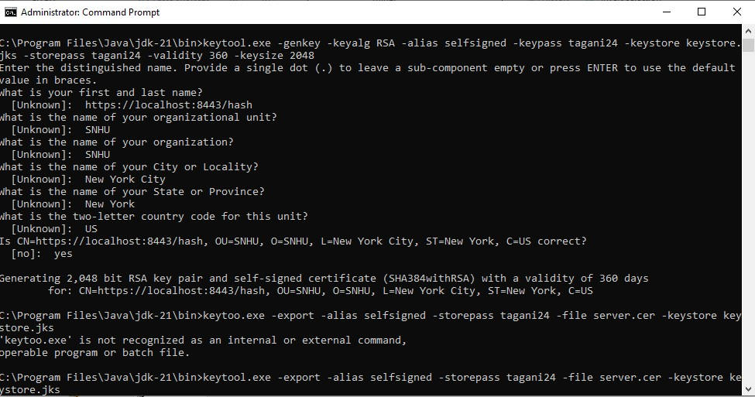

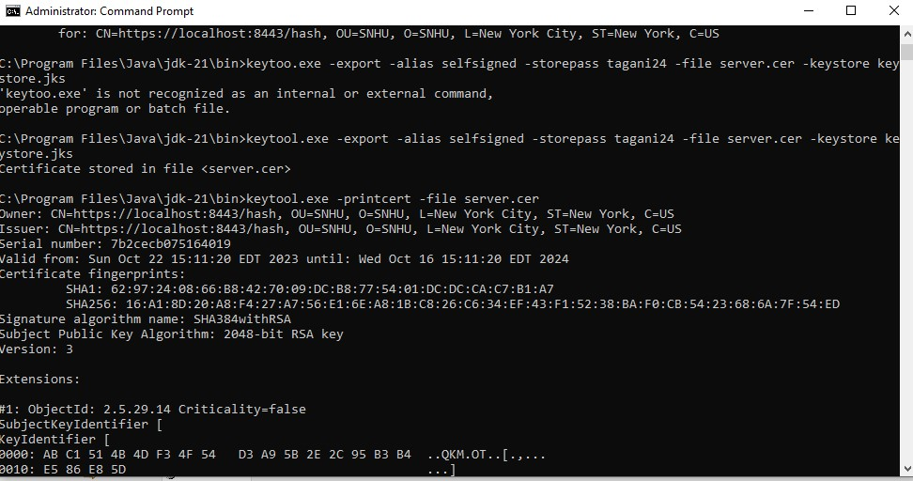

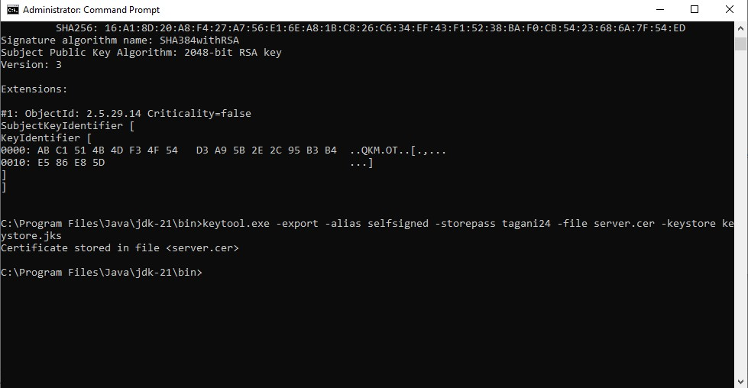

## Deploy Cipher

Insert a screenshot below of the checksum verification.

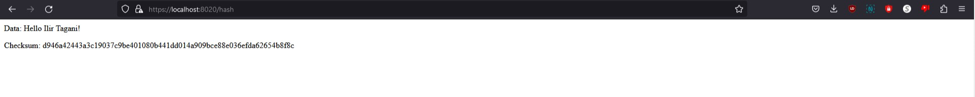

## Secure Communications

Insert a screenshot below of the web browser that shows a secure webpage.

Here I was having so much trouble, I was able to generate a self signed certificate and initialize it but my webpage was not secure no matter how many things I did to try and get it to work. I kept receiving “Failed to create the part’s control” and the error I am receiving from my browser is “The certificate is not trusted because it is self-signed.”. I can still open the webpage but it is not secure. And another issue I kept running into is “Web server failed to start. Port 8443 was already in use”. I closed my browsers and tried different browsers but would keep getting this message while not allowing me to update any of the code.

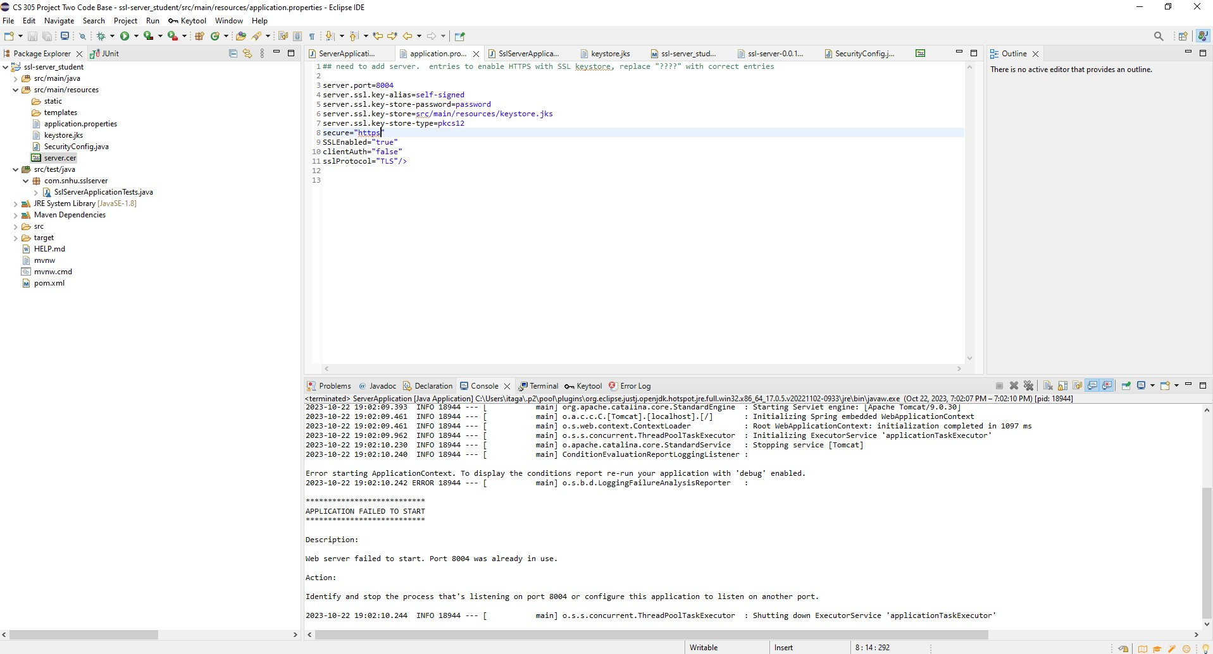

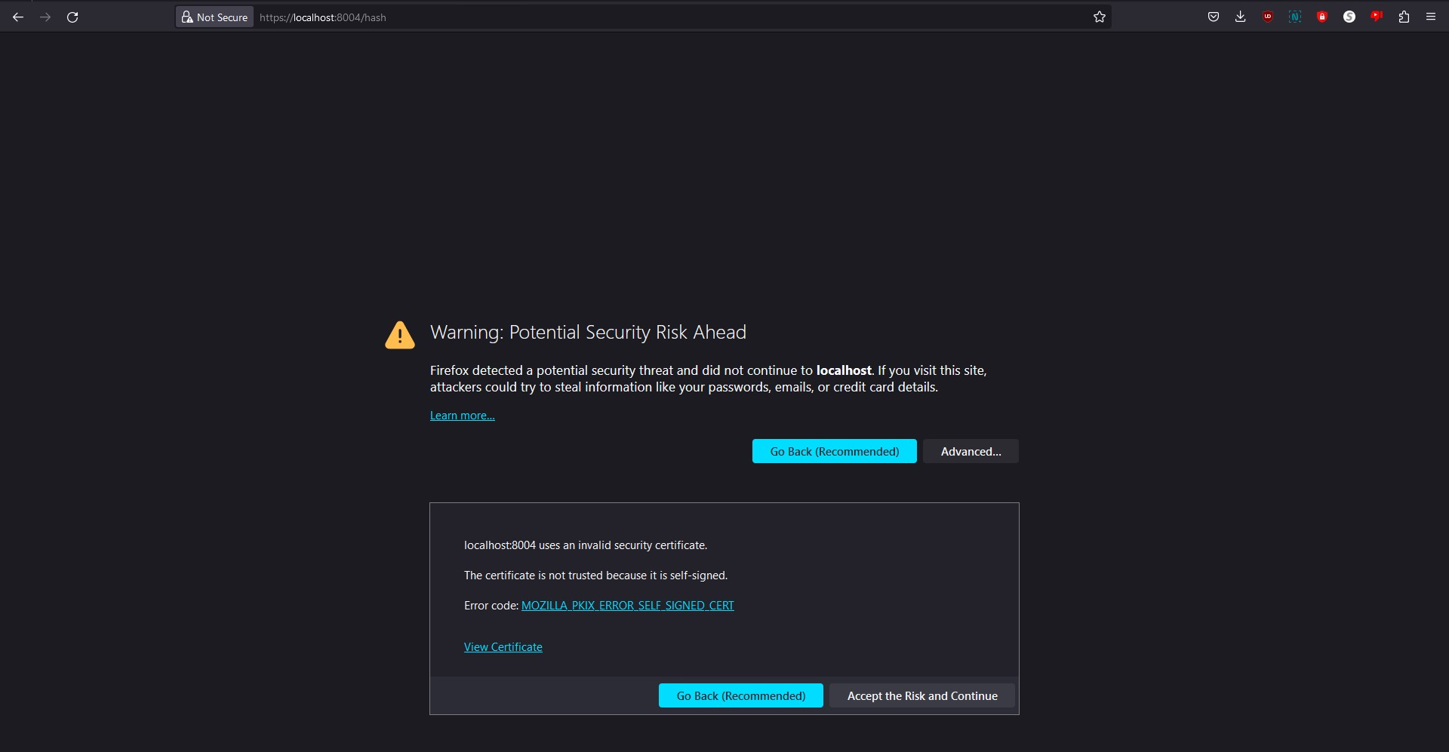

I literally tried everything to get it to work but kept running into the same issue. I deleted the keystore.jks file as well as the server.cer file. Followed the instructions again to from step 1 and kept getting the same message about my self signed certificate not being trusted. Really, really frustrating to say the least.

## Secondary Testing

Insert screenshots below of the refactored code executed without errors and the dependency-check report.

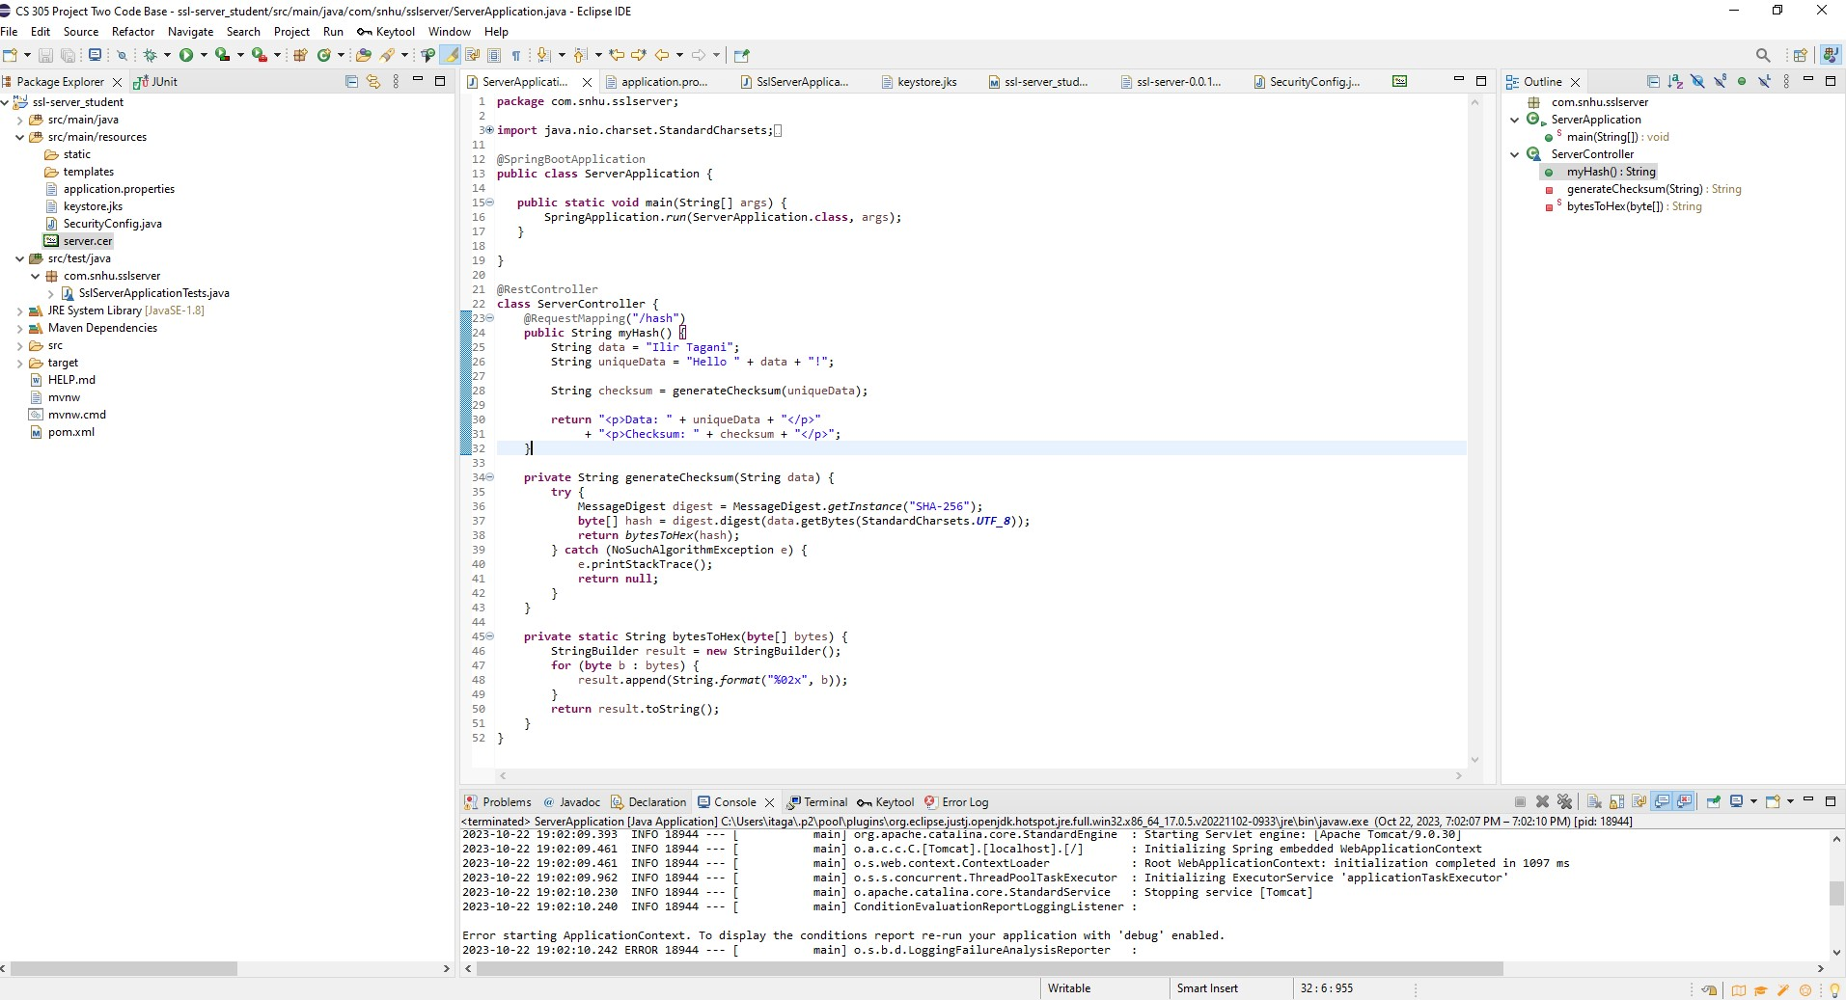

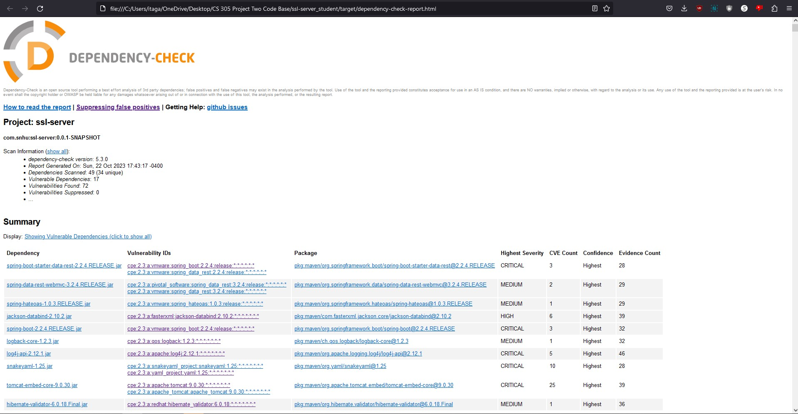

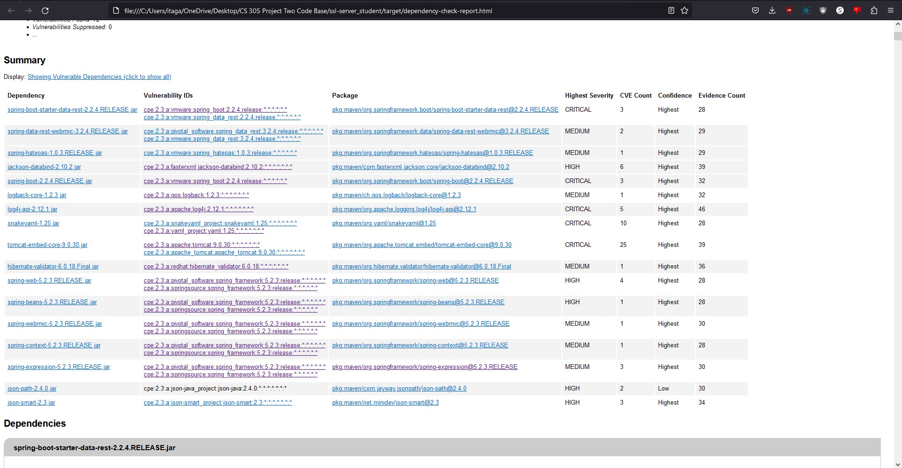

The dependency check did show vulnerabilities that were there before my code was added. No new vulnerabilities were shown with the refactored code taken into consideration.

## Functional Testing

Insert a screenshot below of the refactored code executed without errors.

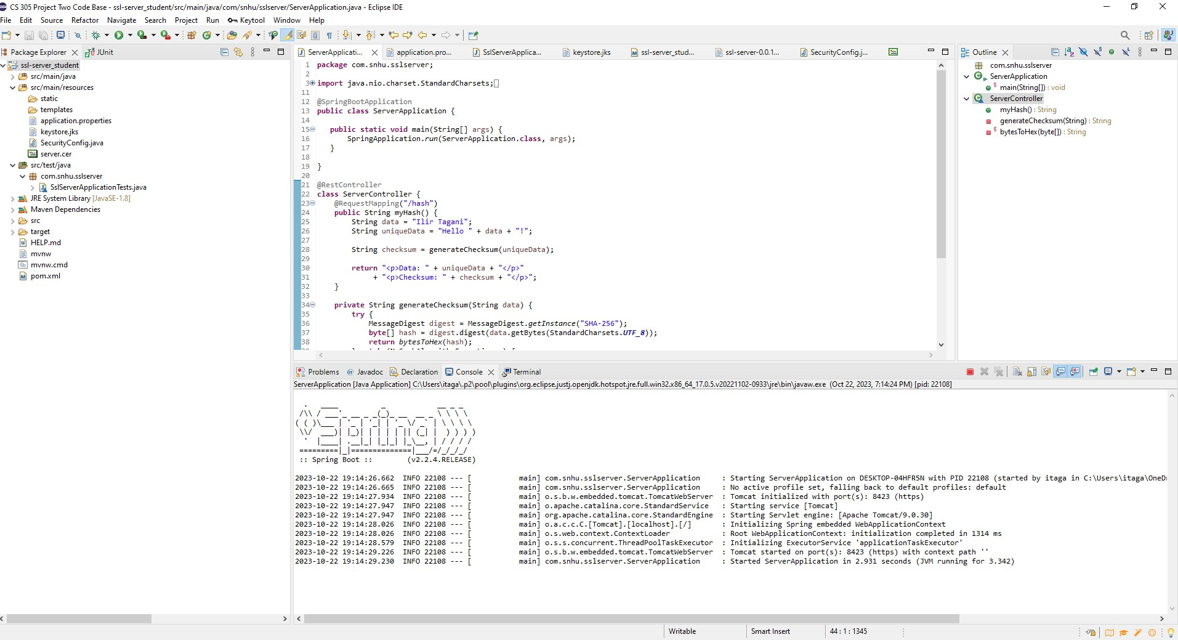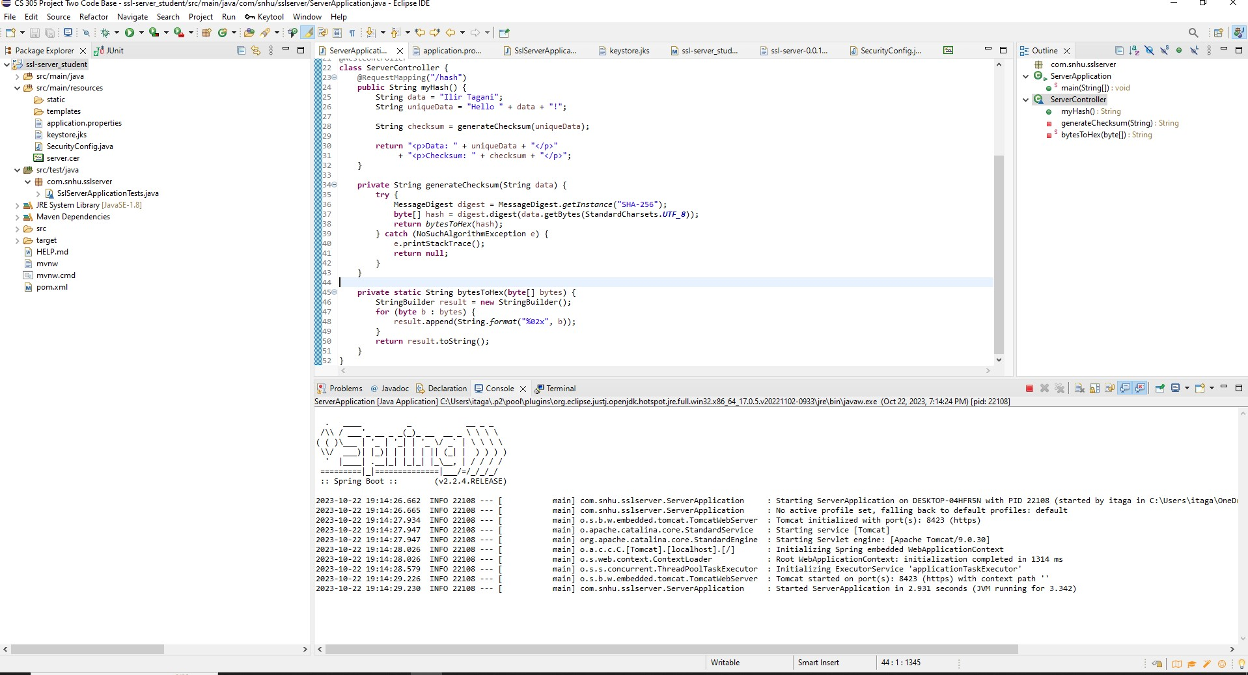



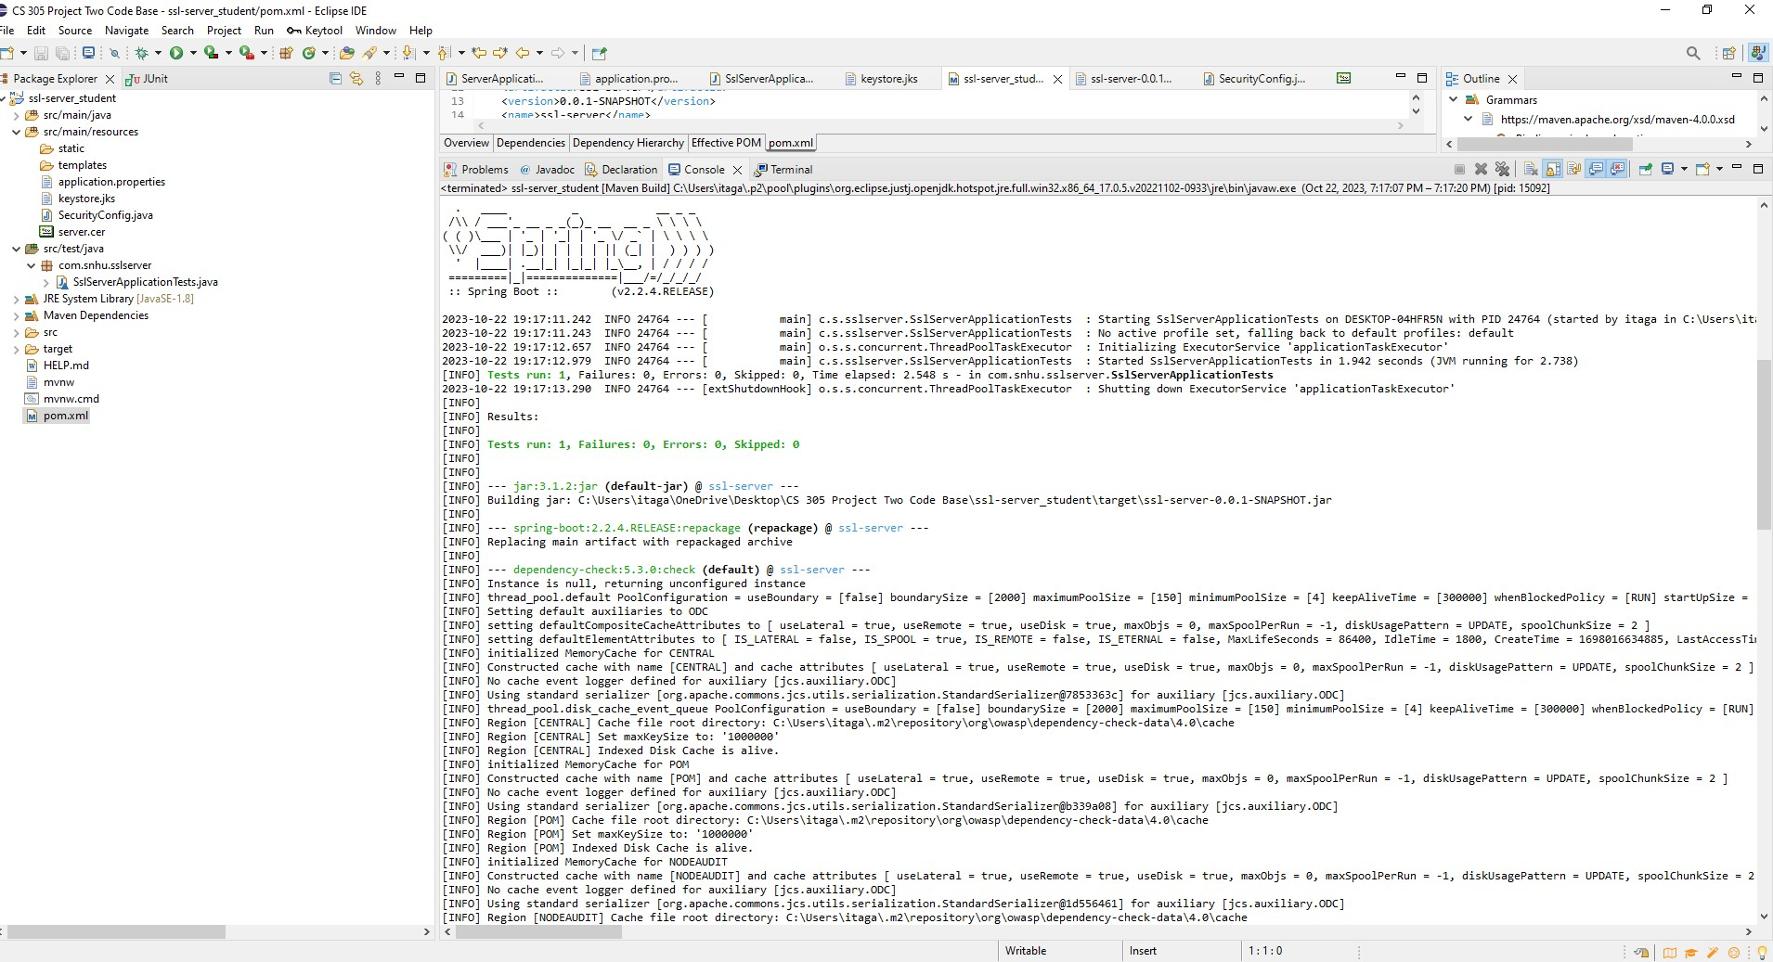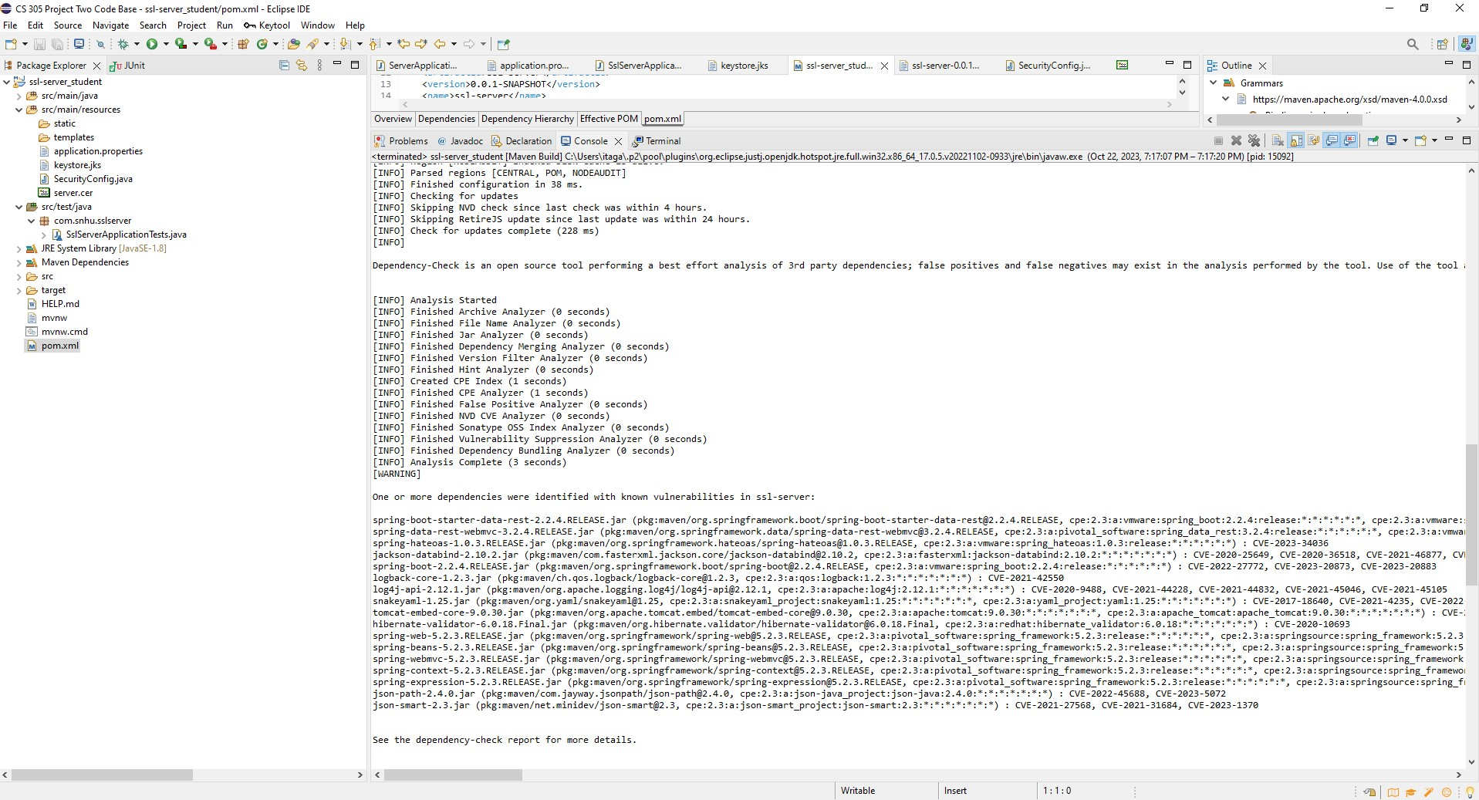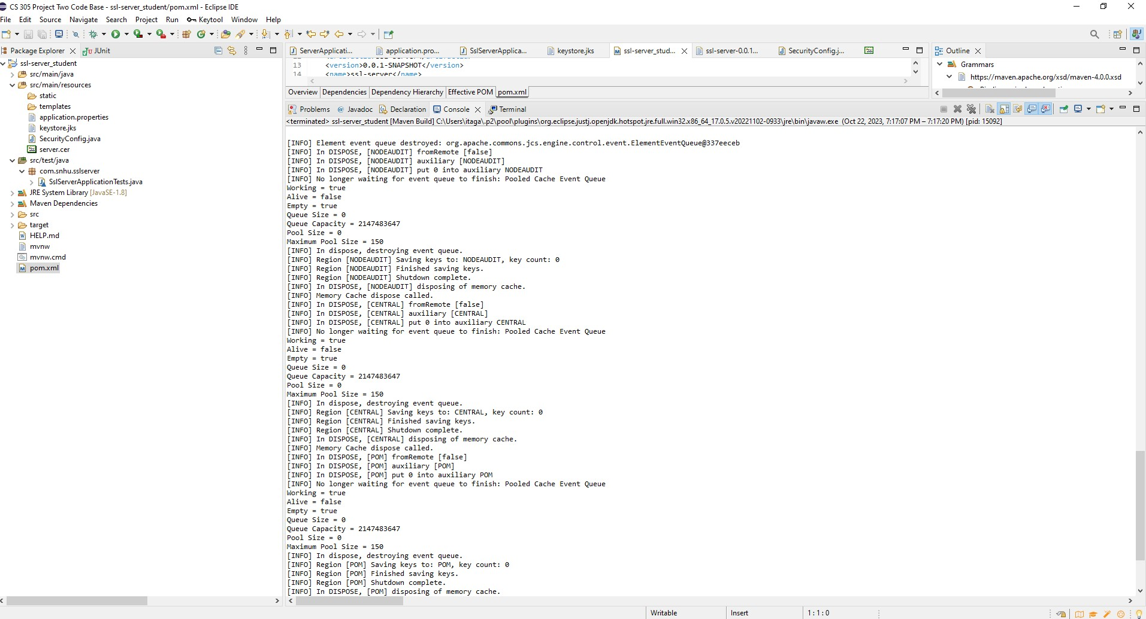

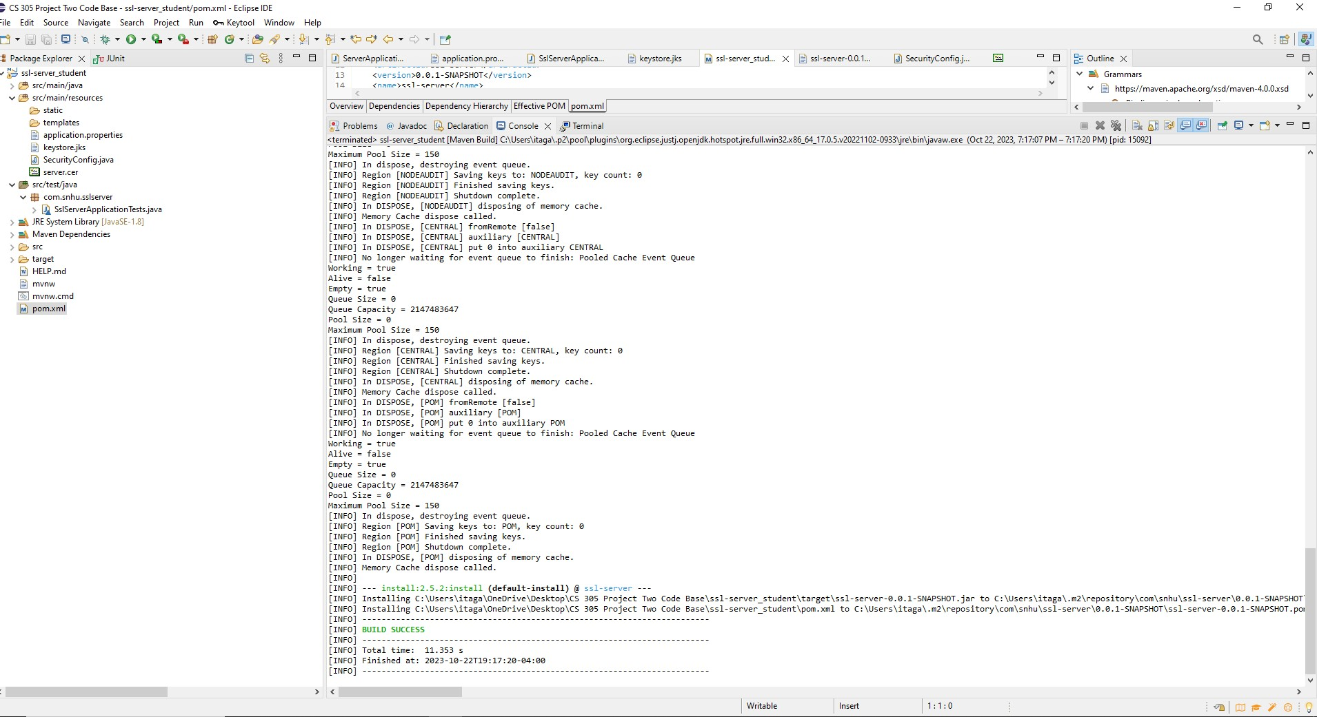

## Summary

Looking at the Assessment Process Flow Diagram these are areas of security that I tried to address:

1. Architecture Review: Once I first opened the project I looked at what was provided and how I need to plan to incorporate security features as well as establishing a secure server. I assessed data encryption abilities which did not exist and added a level of security that enables encryption of data.
2. Code Review: These were the first steps that I took to see what I needed to do and how I could identify any potential vulnerabilities and potential security risks. By adding a hashing algorithm as well as error handling I adhered to security coding standards.
3. Code Quality: Next I focused on code quality. I think I accomplished this by writing code that is easy to read and functions in its simplicity.
4. Hashing Algorithm: By selecting a strong hashing algorithm (SHA-256), this was my foundation to security that would provide a layer of protection to sensitive data.
5. Compliance: I ensured that the system complies with security standards and regulations. Using maven dependency check as a way of seeing where vulnerabilities are and seeing if the refactored code added any new vulnerabilities.

Also using a self-signed certificate which would allow and enable the usage of HTTPS. Sadly I was unable to fully secure localhost which really was troublesome to get to work. There are many steps out there to try and get it to work properly, but after exhausting almost every avenue possible, and spending well over 15 hours looking for a fix, I am settling with the progress I was able to establish.

## Industry Standard Best Practices

The way I incorporated industry standard practices was firstly using a SHA-256 cryptographic algorithm which is considered in the industry as a secure algorithm. When using a strong cryptographic algorithm, taking users personal information and sensitive data is vital and ensuring this type of information is secure is paramount when considering an algorithm cipher. Also documenting the architecture and steps taken when adding security features is something I think I did well and adhered to industry standard best practices.

Applying industry standard practices for secure coding will surely enhance current security of the software application and will contribute to the success of a company. It will also ensure that security breaches, potential data leaks, and also potential financial losses will be minimized. Adhering to industry standards will also ensure that a company can maintain trust with its customers, and investors and will maintain a company's reputation as being secure. In the end secure coding practices as well will are an essential investment when considering the long term security of a company or organization.